TDC CS WEEK-01

Task 3: Encryption Hands-on
(Encrypt and decrypt a message using OpenSSL.)

1. Encryption
Run the following command to encrypt the file using AES-256-CBC:
openssl enc -aes-256-cbc -salt -in message.txt -out encrypted.txt
- Explanation:
  - -aes-256-cbc: Specifies the encryption algorithm.
  - -salt: Adds randomness to encryption for better security.
  - -in message.txt: Input file to encrypt.
  - -out encrypted.txt: Encrypted output file.

2. Decryption
Run this command to decrypt the file:
openssl enc -d -aes-256-cbc -in encrypted.txt -out decrypted.txt
- Explanation:
  - -d: Decrypt mode.
  - -in encrypted.txt: Input file to decrypt.
  - -out decrypted.txt: Output file to save the decrypted content.

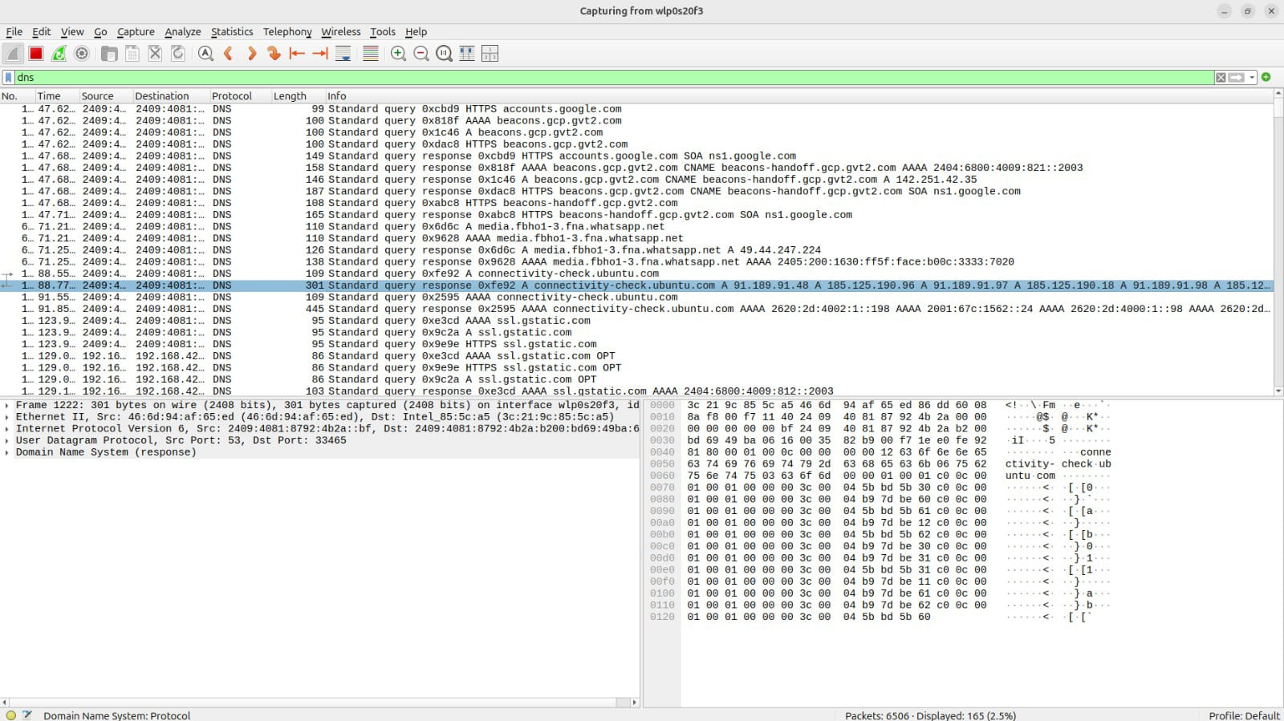

Practically I’ve not done it, didn’t get enough time to explore wireshark and openssl.
Through this I am trying to show you that I have learned using github efficiently, that may of us can’t.
For sure I will do the remaining tasks of the practical implementation in some time.

